Directions: The goal of the following problems is to help challenge and deepen your understanding of the current topic. Don’t assume that you will know how to answer each and every question. You will work with at least two other students in the class to try and find solutions and write arguments for each of the following questions. Be sure that you question your classmates’ reasoning. If you don’t understand how they are getting something you should ASK THEM TO EXPLAIN! Being able to defend your reasoning is important and so you are actually helping them by asking them to explain.

Challenge Questions

- Draw a function that is continuous everywhere except for . Use a different type of discontinuity at each of these values of x.

Note: There are infinitely many correct answers.

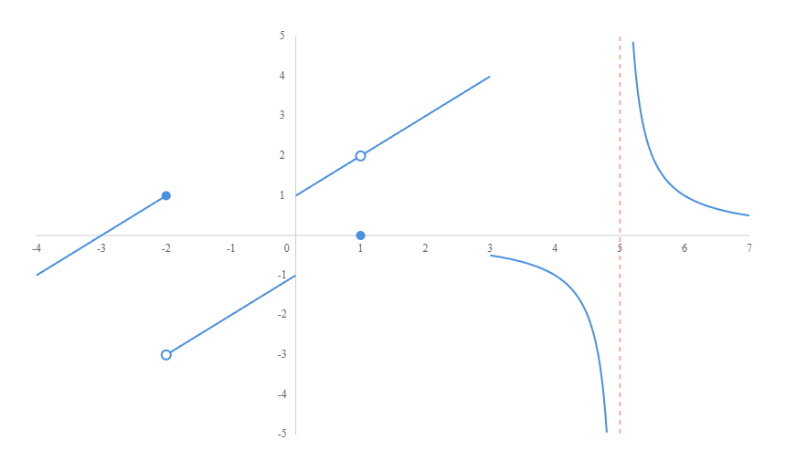

- Determine if the following function is continuous at . .

We note that is a polynomial and therefore it is continuous at all values of x.
OR
We need to see if .

- Is the following piecewise function continuous at ?

Note that the path leading to is on the “top” piece of this function and therefore,
.
We also note that .

Therefore and is continuous at .

- Is the following piecewise function continuous at .

Note that the path leading to is on the “top” piece of this function and therefore,
.
We also note that is undefined.

Therefore and is NOT continuous at .

- Is the following function continuous at ? Justify your answer.

We see that and

We see that and therefore DNE which implies that is NOT continuous at .
- Where is the function continuous?

We start by finding all spots where the function is NOT continuous.
We see that is not continuous at , is always continuous, and is not continuous or equals 0 at all multiples of (that is for all where k is an integer).

Therefore, the function is continuous at all real numbers except where k is an integer.

- For what value of the constant c is the function f continuous for all real numbers?

We see that on and is a polynomial and is therefore continuous on these intervals. The only point in question is when .

Note that and . In order for to exist it must then be the case that . Therefore, if then and so .
We also see that if then .
So, we have that if then which means that is continuous at .
We have established that if then f is continuous for all real numbers.

- Consider the function .
- For what value of a is the function continuous at ?

Note that and . In order for to exist it must then be the case that . Therefore, if then and so .
We also see that if then .
So, we have that if then which means that is continuous at .

- If , what type of discontinuity exists at ? Justify your answer.

If , then we see that . This implies that the two pieces of our function don’t connect and there is a jump discontinuity.

The following questions are related to the Intermediate Value Theorem (IVT)

- Something is wrong with the following ‘proof’. What is it?
Let . When , . When , . There, by the IVT, for some c between and 1.

The issue here is that the IVT requires that the function be continuous on , but we can clearly see that is not defined at and therefore cannot be continuous there. So, the IVT does not apply to on the interval .

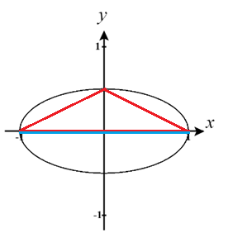
- Let C be the ellipse . How can one use the IVT to show that there is point P on C such that the area of the triangle determined by and C is . Hint: How does the area of the triangle change as one chooses different points on C?

A picture of C is shown below.
If we select a point on C then the area of the triangle that is formed by this point and is . (note that we are only going to consider points where y is positive since the same area is created if y is negative)

We see that is a continuous function on and also note that (as seen with the red and blue triangles in the picture). Therefore, by the IVT there must exist a point c in such that .

- Show that there exists a rectangular box with edges of length , , and for some positive value x so that the volume of the box is equal to its surface area (assume the box has both a top and a bottom).

We note that the volume of this box would be and its surface area is . If these values are to be equal, then we want to find a value of x such that

Let . We see that is a polynomial and is therefore continuous everywhere. Note that and that .

Therefore, by the IVT there must exist a value c within such that .
This implies that there is a value c such that .

